Apple Target Challenge:

- Accuracy:
  - Bullseye 10
  - 1st circle 5
  - 2nd circle 2
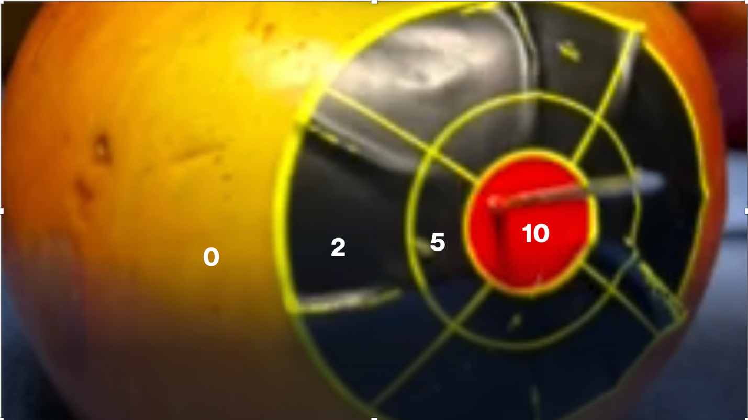
  - Miss 0

- Speed
  - <5 sec 10
  - 5-15 sec 5
  - 15-30 sec 2
  - >30sec 0

- Efficiency/# Passes
  - One 10
  - Two 5
  - Three 2
  - Four or more 0

Total _____/30

